Excercise 8.1.1 - Excercise 8.1.2 - Excercise 8.1.3
Once complete, show your tutor the executing program, and take a screen shot showing the code and output, and include in your submission document.
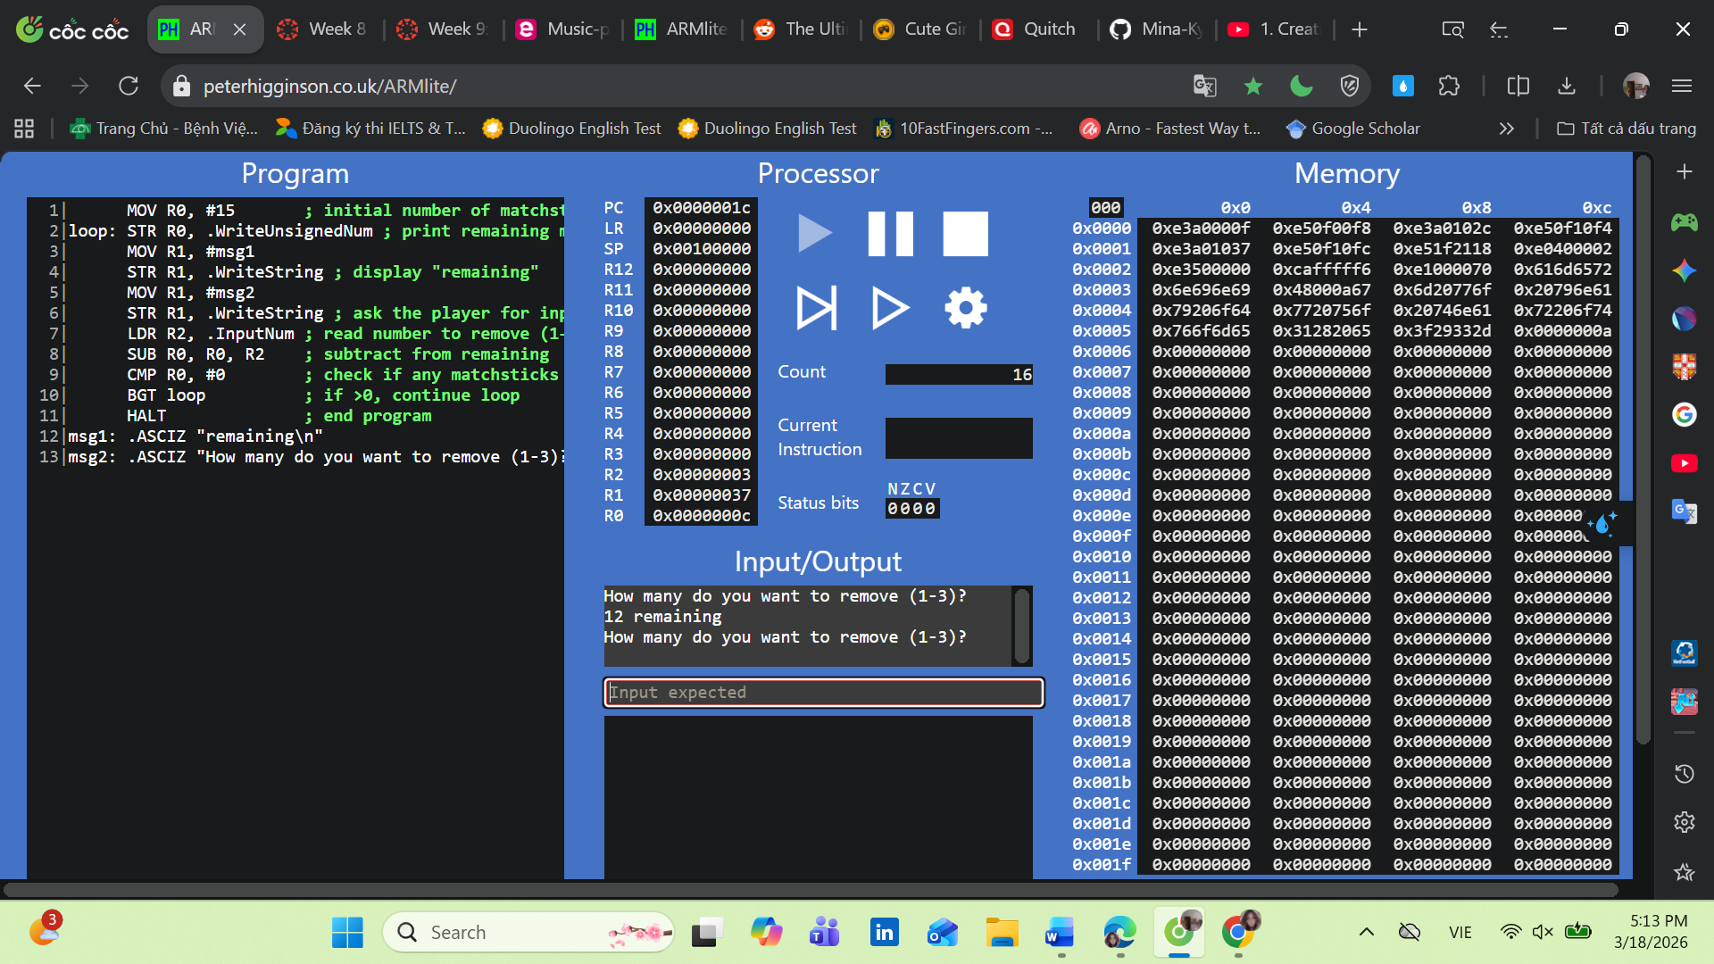
Excercise 8.2.1 - What happens if you enter a number that takes the number of matchsticks remaining beyond 0 (i.e., into negative values) ? What do you think is going on here ? Hint - take a look at the value in the register!
The register R0 simply stores the result of subtraction without validation. ARM assembly does not enforce constraints, so negative values are allowed and the loop continues indefinitely.
Show your program and discuss your answer with your tutor, and take a screenshot of your current program and output and include in your Submission Document.
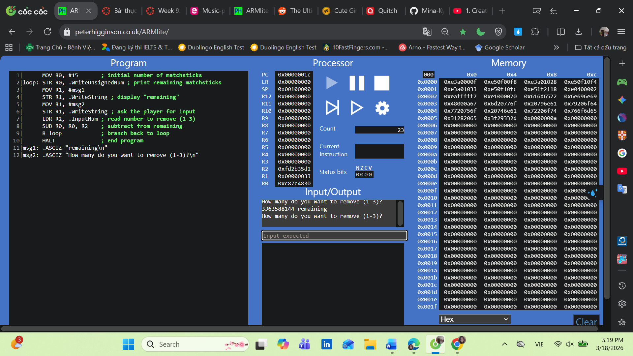
Excercise 8.2.2 - Question 8.2.2(a) - What is the condition that needs to be satisifed in order for this loop to occur ? Write this as a comparison using an inequality (ie., less than, greater than, less than or equal, greater than or equal)
The condition for the loop to occur is when the user input is not between 1 and 3. Inequality form:
Input < 1 OR input >3
Question 8.2.2(b) - What two ARM assembly instructions could be used to create a branch that only occurs under this condition ?
Two ARM assembly instructions that can be used are:
- CMP (compare values)
- Conditional branch instructions such as BLT (branch if less than) or BGT (branch if greater than).
Question 8.2.2(c) - Based on the instructions you outlined in 8.2.2(b), what status bit would be set to 1 if the loop was to repeat ?
The N (Negative) flag is set when the input is less than 1.
For values greater than 3, the condition is evaluated using a combination of flags (N, Z, V) for the BGT instruction.
Question 8.2.2(d) - What are all the modifications needed to the current program to implement this feature ? Make the required modifications to your program to perform the task.
Modifications needed to implement input validation:
- Add a new label (e.g., input_loop) to branch back when input is invalid.
- After reading the input (LDR R2, InputNum), use CMP to compare against 1 and 3.
- If input < 1 (BLT input_loop) or input > 3 (BGT input_loop), branch back to ask again.
- Only proceed to subtract from the remaining matchsticks if the input is valid.
- Continue the main loop until matchsticks reach 0.
Place validation BEFORE subtraction
Enter your answers and a screen shot of your current program and test output into your Submission Document.
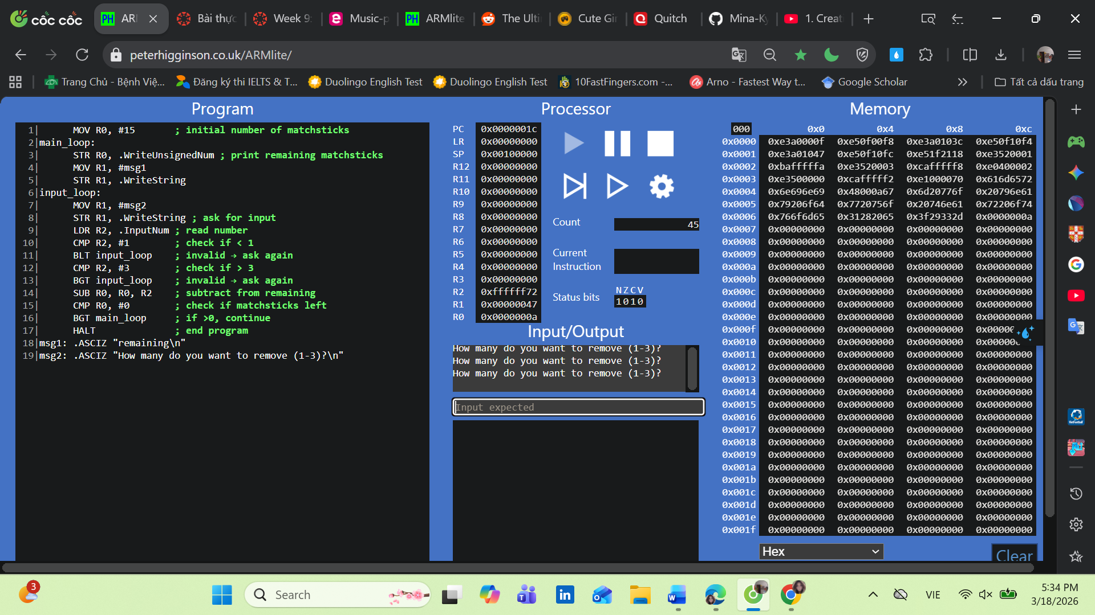
Excercise 8.3.1 - Question 8.3.1(a) What bit-wise operation can we perform on the register holding the 32 bit pattern to set all bits in the register to zero except the least signficant 2 bits ? Write this as a single line of code.
To clear all bits except the least significant 2 bits, we can use a bitwise AND operation with the mask 0x3.
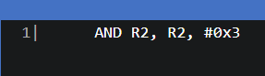
Question 8.3.1(b) Using a label named "select:" Write the code needed to repeatedly sample a random number (from .Random) until the value is in the range 1-3. For now, just write this as a seperate program and test it.
Enter your answers and a screen shot of your current program and test output into your Submission Document.
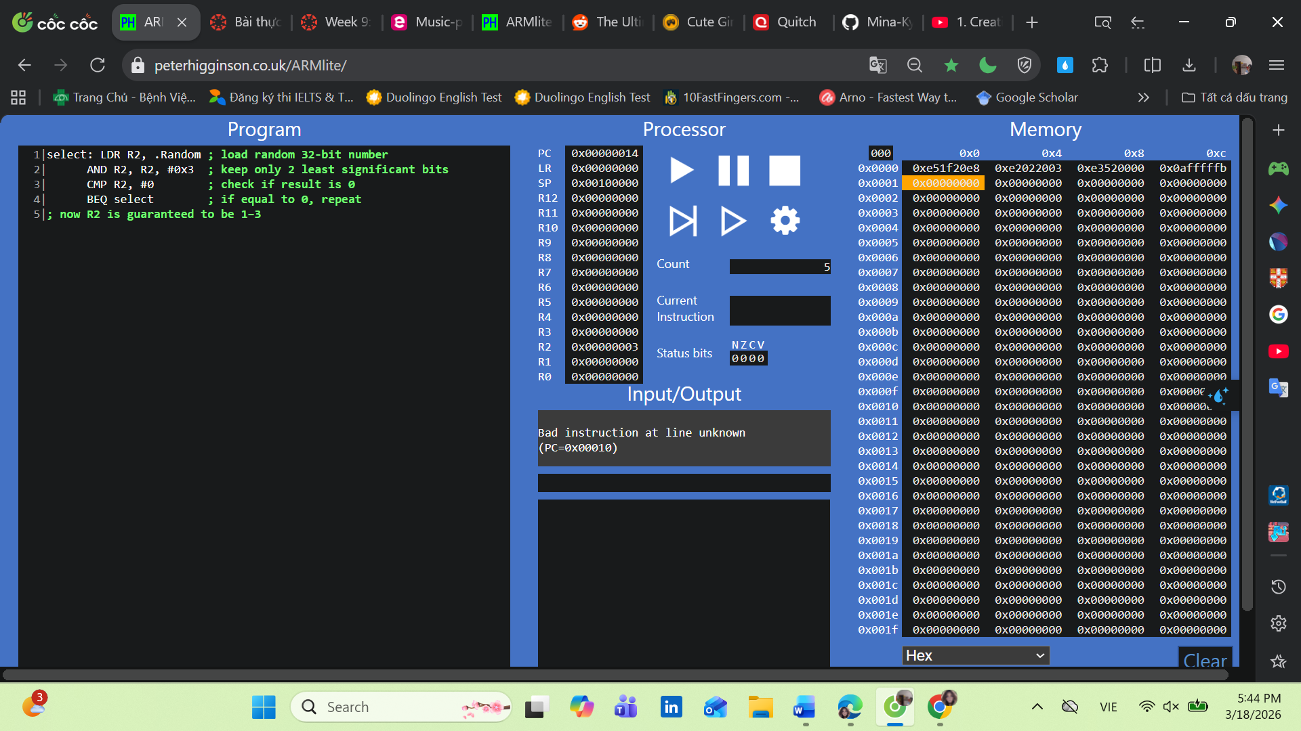
Excercise 8.3.2 - Question 8.3.2(a)
Enter your answers and a screen shot of your current program and test output into your Submission Document.
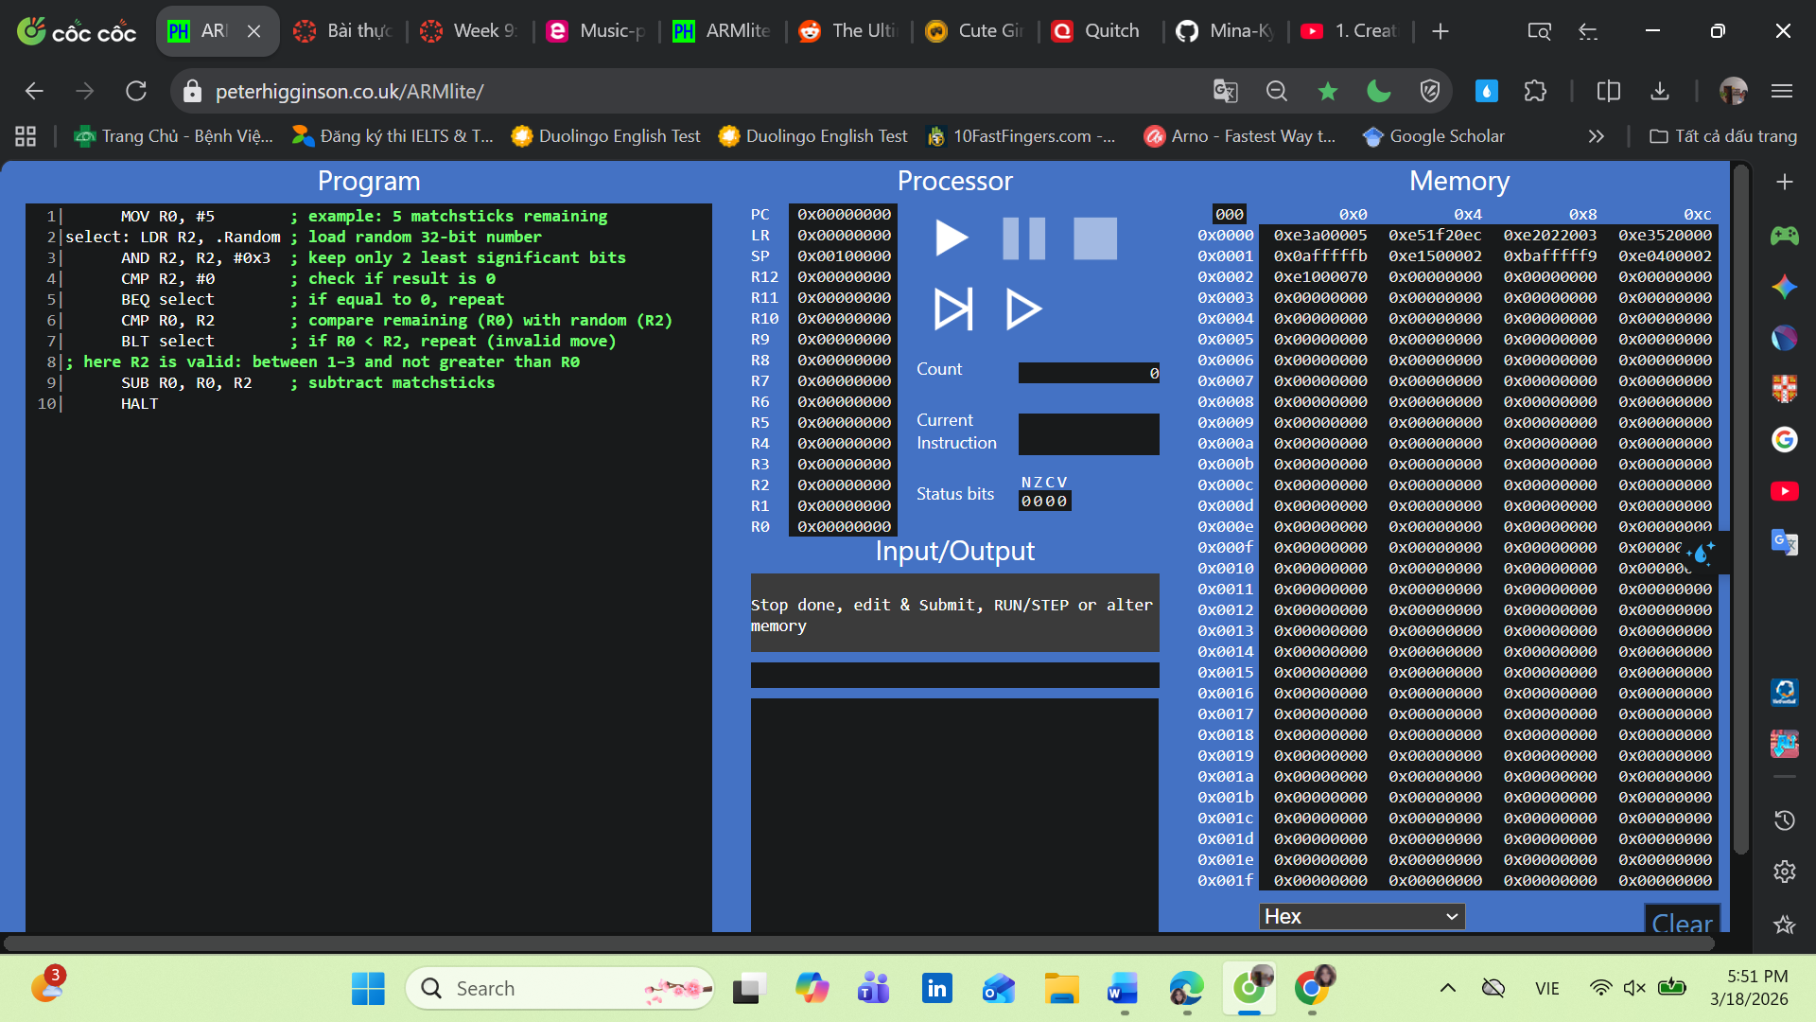
Excercise 8.4
Copy the code of your solution (or reasonable attempt) into your Solution Document.
